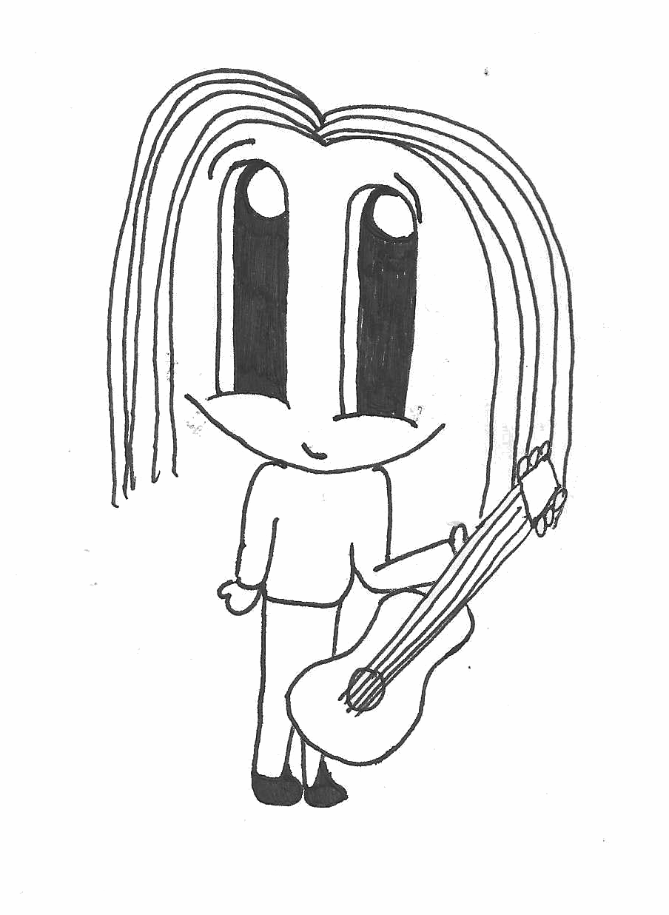
Young Musicians’ Jam Session
Cawoodstock is a new, free, family friendly music, arts and culture festival being held in Cawood for the first time. It’s being organised by the village community for the village, and run entirely by volunteers.
There will be lots of music and arts events going on in existing venues, including some open music ‘jam’ sessions in various places over the weekend. There’s more information at bit.ly/2JrZztc and on our website at www.cawoodstock.org

About the Young Musicians’ Jam Session
As part of Cawoodstock, we thought it would be great to encourage talented and keen young Cawoodian musicians to get involved in a jam session. If you haven’t been to a jamming session before, it’s a fun meetup to play music with other musicians in a local café. Think of it like a big singalong but with instruments as well as singing!
We want young musicians of ANY age to come along and play music with us. Bring your instruments, your lyric sheets (and a parent/guardian for the younger players). We’ll have other musicians there, of all different levels of experience - including some from local bands - to help players and singers sound great.
You could: play a solo instrumental song you know well, or sing a Joseph song along with some friends, sing a pop song with a real band backing, or anything else you like! It’ll be friendly and nobody will feel ‘on the spot’ to play. Anybody can join in with any song and we’ll all have fun and be better musicians!
When? Friday 24th August, 3pm - 6pm Where? The Pickled Postie Café
Questions? ask on the Facebook group (link above)
Capacity: The Pickled Postie is a cosy venue with space for 20-25 young musicians at absolute capacity, so if you are interested please register your interest here: bit.ly/cawoodstock-young-musician-2018

